Online Food Corner

**6th Semester**

**2016-CE-54, 2016-CE-71, 2016-CE-72**

# Instructor Information

|  |  |  |
| --- | --- | --- |
| Instructor | Email |  |
| **Samyan Qayyum Wahla** | [**samyan.uet@gmail.com**](mailto:samyan.uet@gmail.com) |  |

# General Information

## Introduction and Project Description:

In this system “Online Food Corner”, customer can order food online. Customer visits ‘Online Food Corner’, searches and choose different food items from E-Menu Card. These food items then will be delivered to customer by the deliverer team. Payments can be made through cash on delivery. This system has two types of users: Employees, Customers.

Employee can be Admin/Manager, Chef and Deliverer.

1. Administrator manages all basic activities i.e. he/she can view, update, add, delete items from Menu Card. Food items prices are also maintained by administrator. He/she can assign order to chef and delivery team. Records for total purchased items (e.g. salt, raw rice etc) and sell items customers and other employees’ registration info are also kept for security purposes.
2. Deliverer manages the delivery status and confirm the payment made by customer on delivery.
3. Chef can view his/her order that is assigned to him. And update the status that whether food is ready or not.

Customers can search food items, add to cart and purchase them after login to their registered accounts, view delivery status and pay charges on delivery time. They can also give their feedbacks.

## Business Rules:

Following are some assumed business rules:

* Each staff member must have an account.
* Customers shall be given access to the menus, for restaurant, online.
* Customers should register themselves before confirming their order.
* No staff member can register himself/herself. Only Administrator can register/delete, update staff member or customer account.
* Only manager(administrator) can change the food menu. He/ She can also update items price.
* Only administrator can order, check and purchase food grocery (salt, vegetables etc ) and maintains records of purchased items.
* Customers must be able to choose more than 1 food items at a time, in cart. After confirmation, they can order their food.
* All meals in a single order must be paid by using the same payment method.
* Order price is calculated as the sum of each food item price times the quantity of that food item ordered.
* Delivery team must deliver food within required time to the customer, assigned by manager.

# Diagram and Design

## Conceptual Diagram:

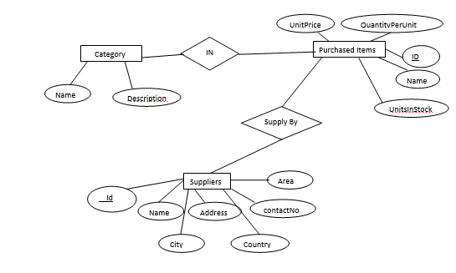

ER Diagram 1

## 

ER Diagram 2

## Logical Database Design:



## Reports:

* List of orders and their details that a customer orders at specific time.
* List of registered employees with their salaries and designation.
* Number of employees working at each designation.
* List of registered customers.
* Feedback given by customers order by date.
* Number of customers and total sale price on daily basis.
* An order’s status, total price and discount price can be listed in a report.
* Categories of menu card along with total number of items they have.
* Details of vehicles owned by delivery team i.e. through which vehicle, the deliverer delivers food to which customer.
* List of products along with their categories and supplier names.
* Orders assigned to each chef and status of each order (i.e. urgent or not)

# Technology to be used

## For Frontend:

HTML, CSS, Javascript, Bootstrap, Sublime, Just in Mind

## For Backend:

MSSQL, Visual Studio(MVC), C#, SAP Crystal Reports (for generating reports)